

HAJJSAFE | حج آمن
A Smart Platform for Detecting Hajj Scams, Misinformation, and Unauthorized Services Using Artificial Intelligence

Prepared By
• Wasan Aljohani (وسن الجهني)
• Nora AlDakhil (نورة الدخيل)
• Rakan Alshammari (راكان الشمري)
Supervisor
Dr. Maha (د. مها)

Prepared for
Tuwaiq Academy – Hajj & Umrah Innovation Track
June 2026

Abstract
HajjSafe AI is an intelligent multilingual platform developed to protect pilgrims from scams, misinformation, fake Hajj campaigns, suspicious links, and unauthorized services during the Hajj season. The system utilizes Artificial Intelligence (AI), Natural Language Processing (NLP), and Machine Learning techniques to analyze messages in both Arabic and English languages. By automatically classifying content into predefined categories and assigning risk levels, HajjSafe AI helps authorities and pilgrims identify harmful content quickly and efficiently. The solution contributes to improving digital safety, supporting Saudi Vision 2030, and enhancing the overall Hajj experience.

TABLE OF CONTENTS
Abstract
- Problem Statement……………………………………………………………………
- Target Users………..………………………………………………………………
- Dataset………………………………………………………………………………
3.1 Message Categories……………………………………………………………………………
3.2 Dataset Characteristics………………………………………………………………………
- Preprocessing…………………………………………………………………………
4.1 Arabic Text Processing……………………………………………………………
4.2 English Text Processing……………………………………………………………
4.3 Additional Processing……………………………………………………………
- EDA & Visualizations…………………………………………………………………
- Model & Algorithm……………………………………………………………
6.1 Text Representation………………………………………………………………
6.2 Machine Learning Models…………………………………………………………
6.3 Selected Model……………………………………………………………………
- Model Evaluation……………………………………………………………………
7.1 Evaluation Metrics…………………………………………………………………
7.2 Final Results……………………………………………………………………
- MVP (Minimum Viable Product) ……………………………………………………
8.1 Core Features……………………………………………………………………
8.2 Workflow……………………………………………………………………
8.3 MVP Screens……………………………………………………………………
- Demo – How It Works………………………………………………………………
- Business Model Canvas……………………………………………………………………
10.1 Key Partners……………………………………………………………………
10.2 Key Activities……………………………………………………………………
10.3 Value Proposition…………………………………………………………………
10.4 Customer Segments………………………………………………………………
10.5 Revenue Streams…………………………………………………………………
- Future Improvements…………………………………………………………………
11.1 Advanced AI Models………………………………………………………………
11.2 Platform Expansion………………………………………………………………
11.3 Additional Capabilities……………………………………………………………
- Conclusion………………………………………………………………………
- References………………………………………………………………………………
1. Problem Statement
Every Hajj season, millions of pilgrims rely on social media platforms, messaging applications, and websites to obtain information regarding Hajj services. Unfortunately, these platforms are frequently exploited by fraudsters who spread misleading information, fake Hajj offers, phishing links, and unauthorized services.
The rapid spread of digital content makes manual monitoring difficult and inefficient. As a result, pilgrims may become victims of financial fraud, misinformation, or unsafe recommendations.
Therefore, there is a need for an intelligent automated system capable of detecting harmful content, classifying threats, and providing trustworthy guidance to pilgrims in real time.

2. Target Users
The proposed solution is designed to serve multiple stakeholders within the Hajj ecosystem.
Primary Users
- Pilgrims
- Ministry of Hajj & Umrah
- Cybersecurity Teams
- Government Authorities
Secondary Users
- Licensed Hajj Campaigns
- Researchers
- Digital Safety Organizations
- Travel and Tourism Service Providers

3. Dataset
The dataset consists of Hajj-related messages collected from both official and unofficial digital sources. The data was carefully labeled to ensure accurate model training and evaluation.
Message Categories
- Official Information
- Misinformation
- Scam Services
- Suspicious Links
- Violation Promotion
Dataset Characteristics
- Arabic and English content
- Risk level annotations
- Human-reviewed labels
- Real-world Hajj scenarios
- Balanced category distribution

4. Data Preprocessing
Before training the machine learning models, the collected data underwent several preprocessing steps to improve quality and consistency.
Arabic Text Processing
- Remove Tashkeel (Diacritics)
- Normalize Arabic letters
- Remove stop words
- Apply stemming and lemmatization
English Text Processing
- Convert text to lowercase
- Remove punctuation
- Remove stop words
- Normalize contractions
- Replace URLs with placeholders
Additional Processing
- Duplicate removal
- Missing value handling
- Label encoding
- Text normalization
These steps significantly improved model performance and reduced noise within the dataset.

5. EDA & Visualizations
This section shows the number of samples available in each category of the dataset,
It helps evaluate whether the dataset is balanced or if some categories contain significantly more samples than others.
Understanding the category distribution is important because class imbalance can affect model performance and lead to biased predictions toward the majority classes.
- 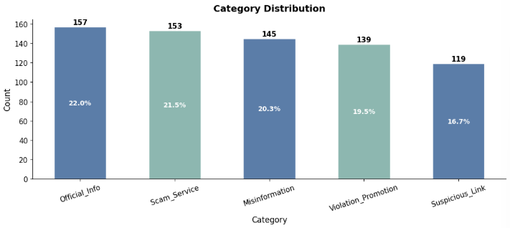
This section illustrates the number of samples in each risk level category within the dataset.
It helps identify whether the risk levels are evenly distributed or if certain levels are overrepresented.
Analyzing the risk level distribution is important for ensuring balanced model training and improving prediction reliability across all risk categories.
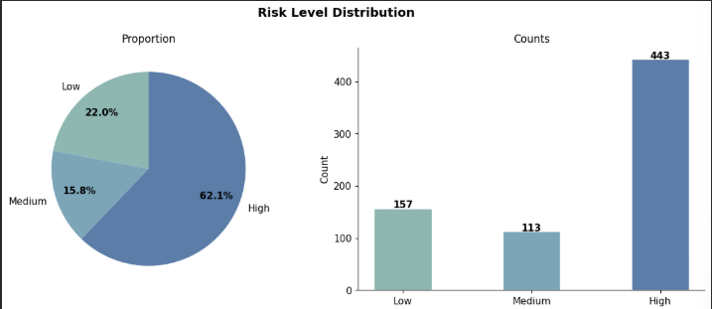

This section shows the distribution of text lengths across different categories in the dataset.
It helps analyze whether some categories contain longer or shorter texts compared to others.
Understanding text length patterns can provide insights into the dataset characteristics and help improve preprocessing and model performance.
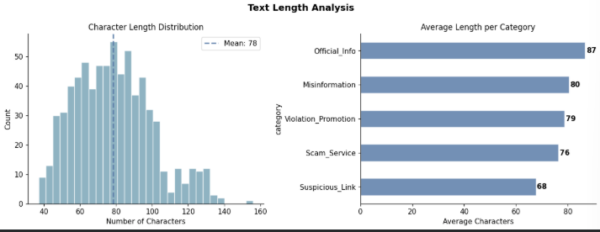
6. Model & Algorithm
The project uses Natural Language Processing and Machine Learning techniques to classify Hajj-related messages.
Text Representation
The messages were converted into numerical vectors using:
paraphrase-multilingual-MiniLM-L12-v2
This embedding model provides strong semantic understanding across both Arabic and English languages.
Machine Learning Models
Two models were trained and evaluated:
- Logistic Regression
- LinearSVC
Selected Model
LinearSVC was selected because it achieved the highest performance across all evaluation metrics.
Advantages:
- Fast inference time
- High accuracy
- Strong generalization
- Robust performance on multilingual data

7. Model Evaluation
The model was evaluated using multiple performance metrics.
Evaluation Metrics
- Accuracy
- Precision
- Recall
- Macro F1 Score
Final Results
Metric | Score
Accuracy | 92.3%
Macro F1 Score | 0.91
Cross Validation Score | 0.90
The results demonstrate that the model can reliably identify harmful content and classify messages with high accuracy.

8. MVP (Minimum Viable Product)
The MVP represents the first functional version of HajjSafe AI.
Core Features
- Message input interface
- Language detection
- AI-powered classification
- Risk assessment engine
- Decision explanation
Workflow
- User enters a message.
- The system preprocesses the text.
- The AI model analyzes the content.
- The risk engine assigns a risk level.
- The result is displayed with an explanation.
MVP Screens
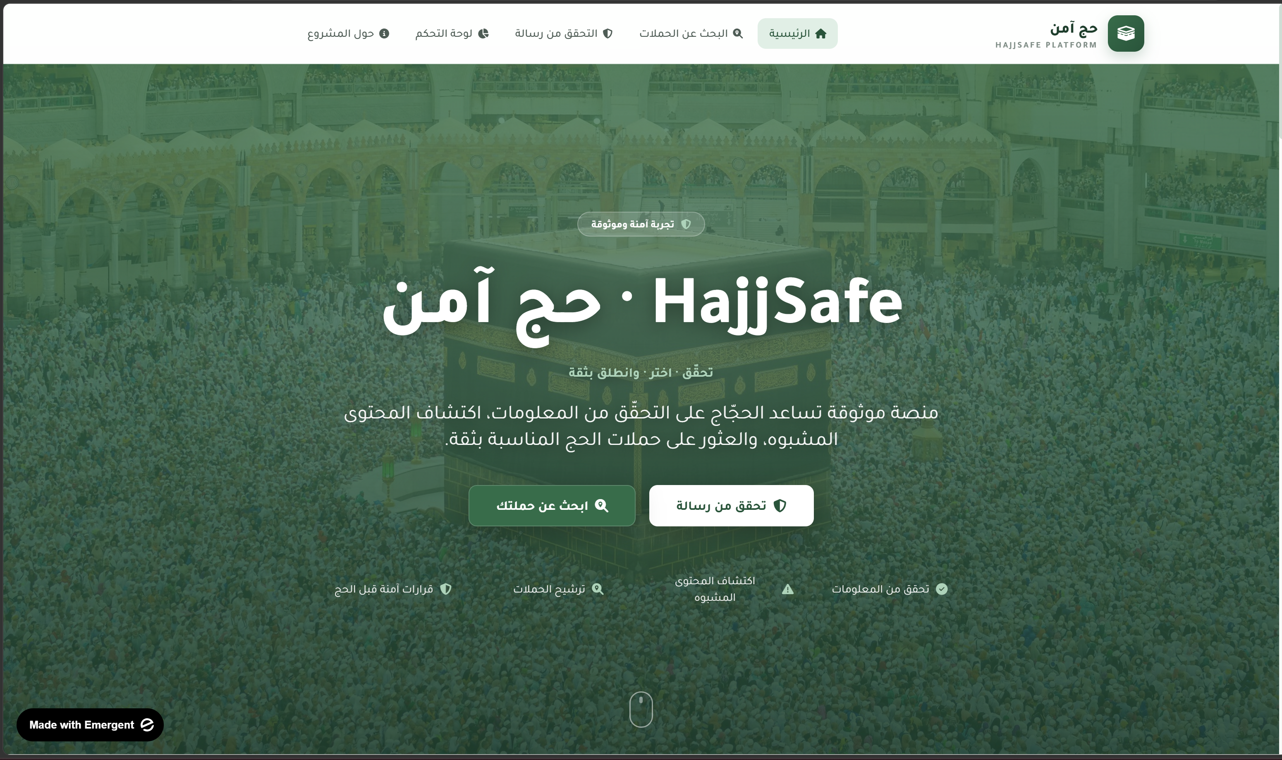

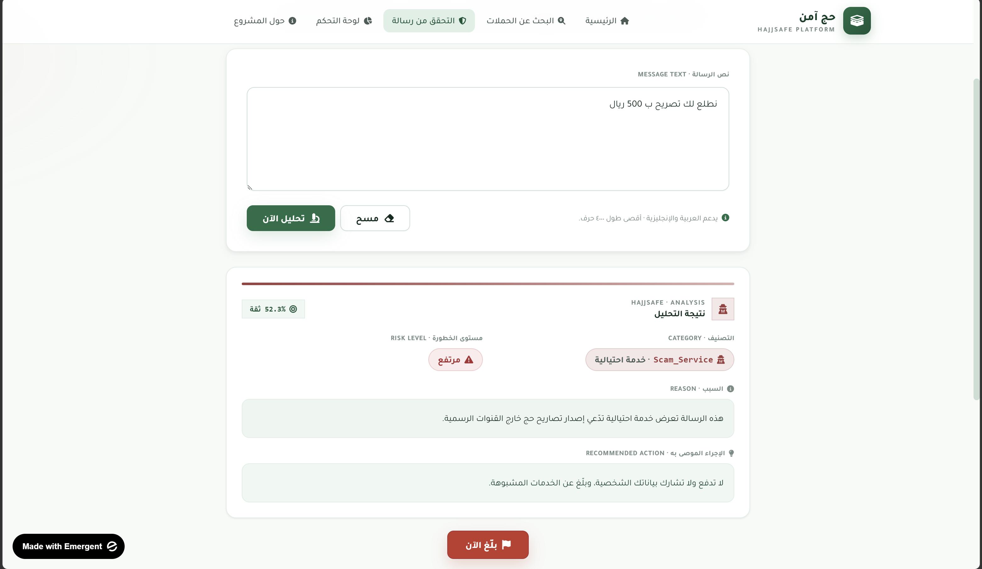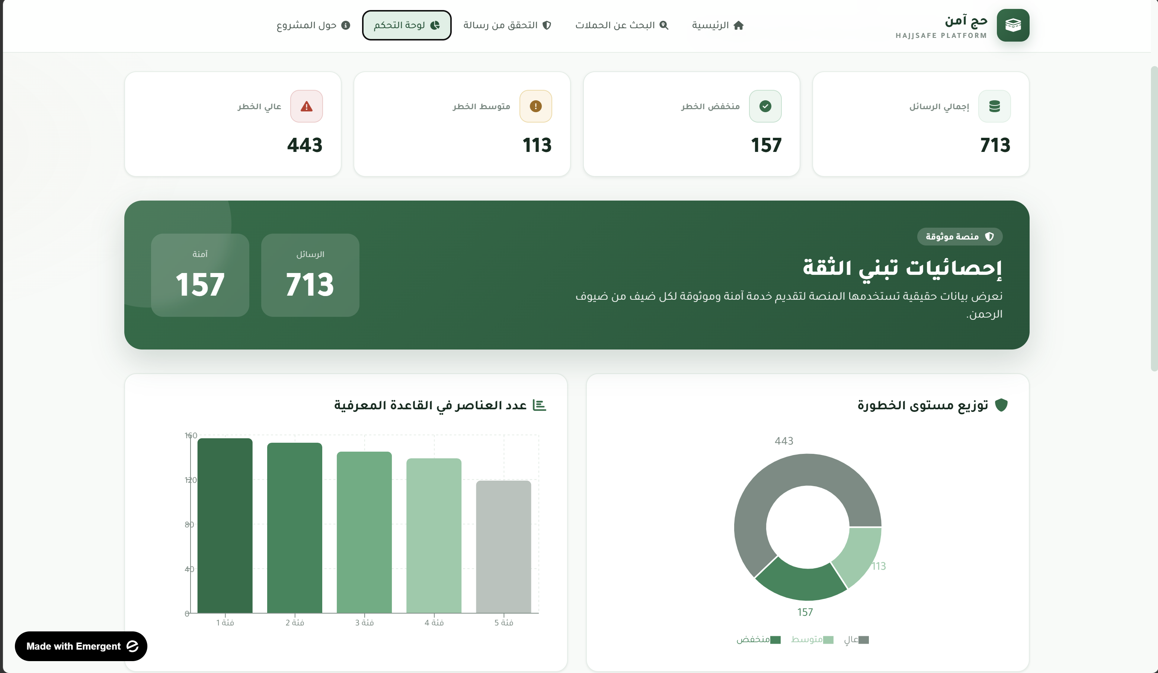

9. Demo – How It Works
The system follows a simple yet effective workflow.
Step 1
User submits a message.
Step 2
The text is cleaned and preprocessed.
Step 3
Semantic embeddings are generated.
Step 4
The machine learning model predicts the category.
Step 5
The risk engine calculates the risk level.
Step 6
The result and explanation are displayed to the user.

10. Business Model Canvas
Key Partners
- Ministry of Hajj & Umrah
- SDAIA
- Cybersecurity Authorities
- Licensed Hajj Providers
Key Activities
- Fraud Detection
- Content Monitoring
- Risk Analysis
- AI Model Maintenance
Value Proposition
Protect pilgrims from scams, misinformation, and fraudulent services in real time.
Customer Segments
- Government Agencies
- Hajj Service Providers
- Pilgrims
- Digital Safety Organizations
Revenue Streams
- Government Contracts
- API Licensing
- SaaS Subscriptions
- Enterprise Partnerships

11. Future Improvements
Future development plans include:
Advanced AI Models
- Arabic BERT
- AraBERT
- Large Language Models (LLMs)
Platform Expansion
- Mobile Applications
- Web Dashboard
- Real-Time Monitoring System
Additional Capabilities
- Image Analysis
- Video Analysis
- Voice Scam Detection
- Social Media Integration
These enhancements will increase the system's effectiveness and scalability for future Hajj seasons.

12. Conclusion
HajjSafe AI demonstrates how Artificial Intelligence can be used to improve digital safety during one of the world's largest annual gatherings.
By combining multilingual Natural Language Processing, Machine Learning, and risk assessment techniques, the platform successfully identifies scams, misinformation, suspicious links, and unauthorized Hajj services.
With an accuracy of 92.3% and strong multilingual capabilities, HajjSafe AI has the potential to become a valuable digital safety solution that supports pilgrims, government agencies, and Saudi Arabia's Vision 2030 objectives.

References:
1.Reimers, N., & Gurevych, I. (2019). Sentence-BERT: Sentence Embeddings using Siamese BERT-Networks. Proceedings of the 2019 Conference on Empirical Methods in Natural Language Processing (EMNLP).
2.Pedregosa, F., Varoquaux, G., Gramfort, A., Michel, V., Thirion, B., Grisel, O., et al. (2011). Scikit-learn: Machine Learning in Python. Journal of Machine Learning Research, 12, 2825–2830.
3.McKinney, W. (2010). Data Structures for Statistical Computing in Python. Proceedings of the 9th Python in Science Conference, 51–56.
4.Hunter, J. D. (2007). Matplotlib: A 2D Graphics Environment. Computing in Science & Engineering, 9(3), 90–95.
5.Vaswani, A., Shazeer, N., Parmar, N., Uszkoreit, J., Jones, L., Gomez, A. N., et al. (2017). Attention Is All You Need. Advances in Neural Information Processing Systems (NeurIPS).

